**1.Translator:**

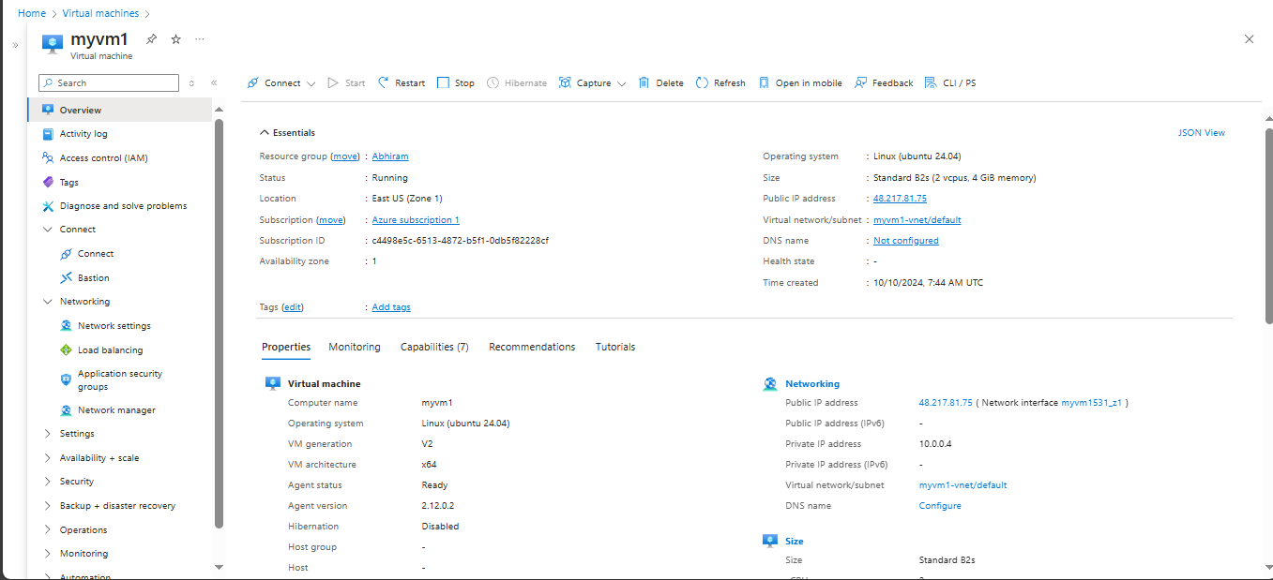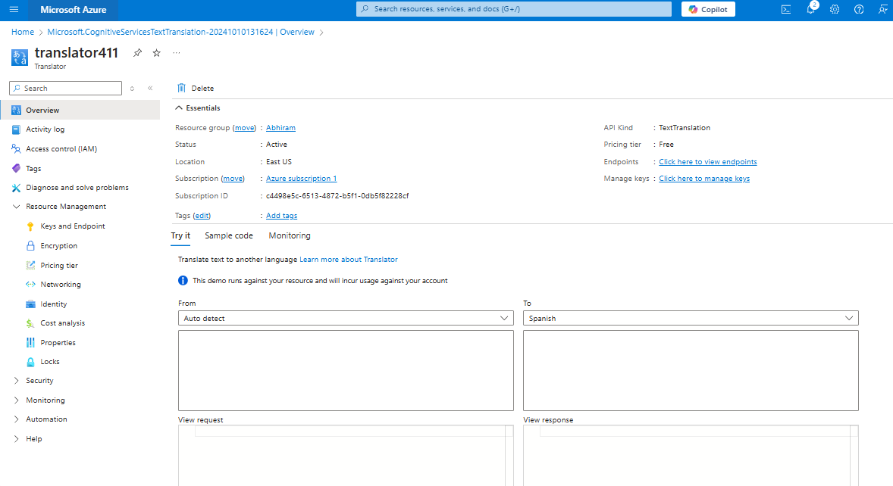

* **Create a Vritual Machine with Ubentu software**
* **Then created the Microsoft Cognative Service Text Translator**
* **The created a code to acces the translator in the vritual machine**
* **In that code I had added the key value and the endpoint**
* **After adding I had ssh to the Vritual Machine**
* **And then installed the software like sudo apt update**
* **sudo apt install python3-pip,sudo apt install python3-requests, sudo apt install python3-pillow, sudo apt install python3-flask**

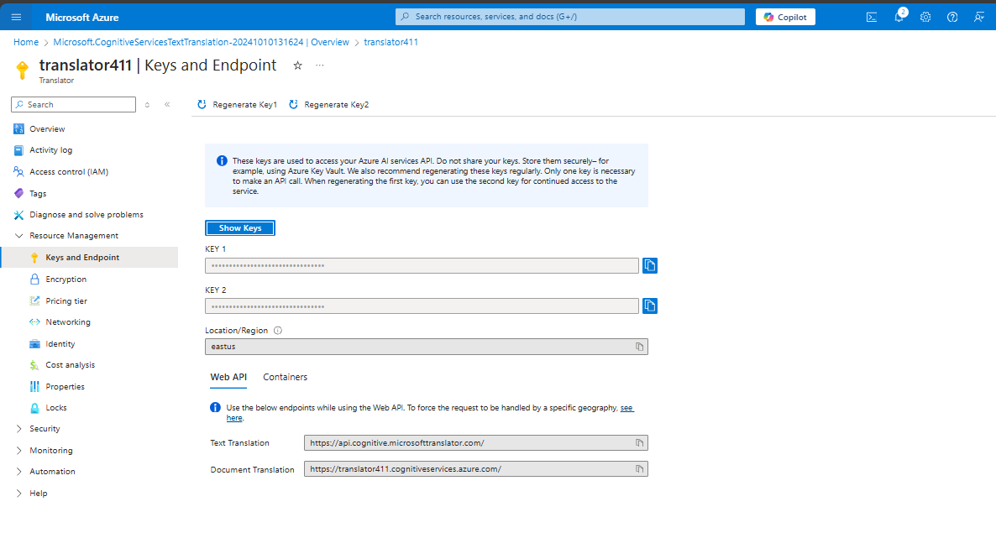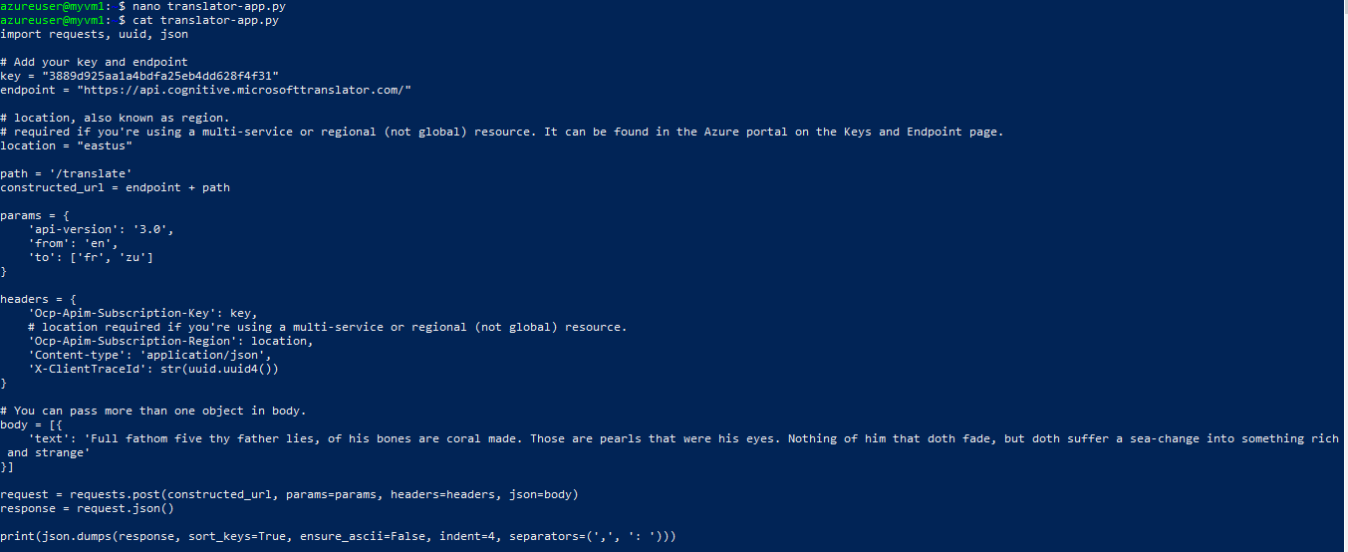

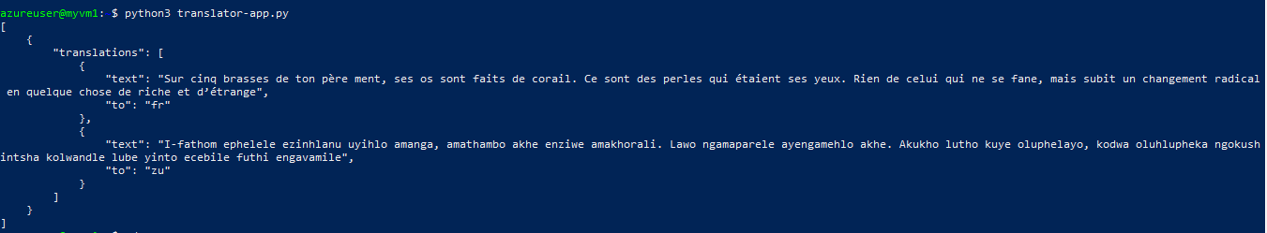

* **After insalling I had created a nono translator-app.py folder**
* **Then added the code into the folder also the text is included in it**
* **Then viewed by using cat translator-app.py**
* **To run that I used the code pythin3 translator-app.py**

**2.Image to text**

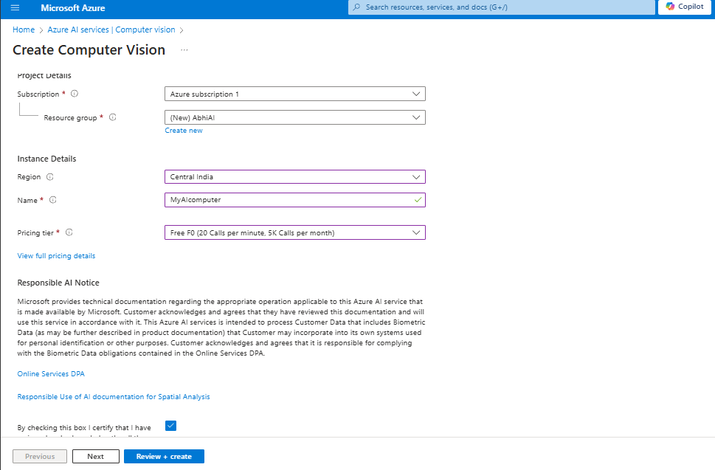

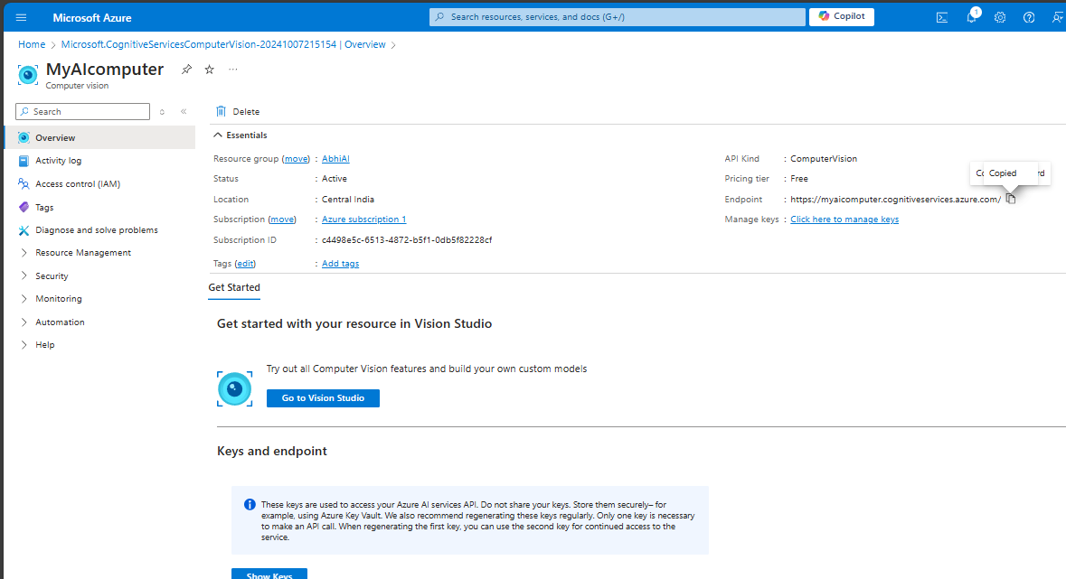

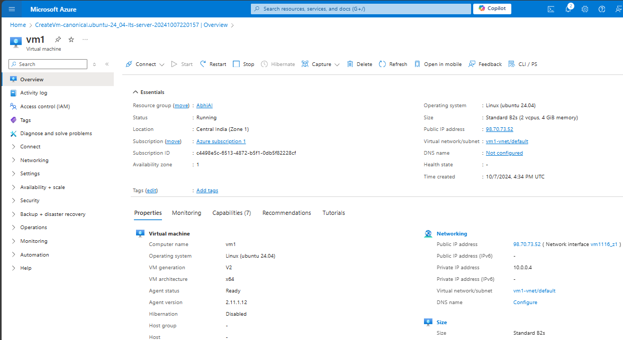

**Created** 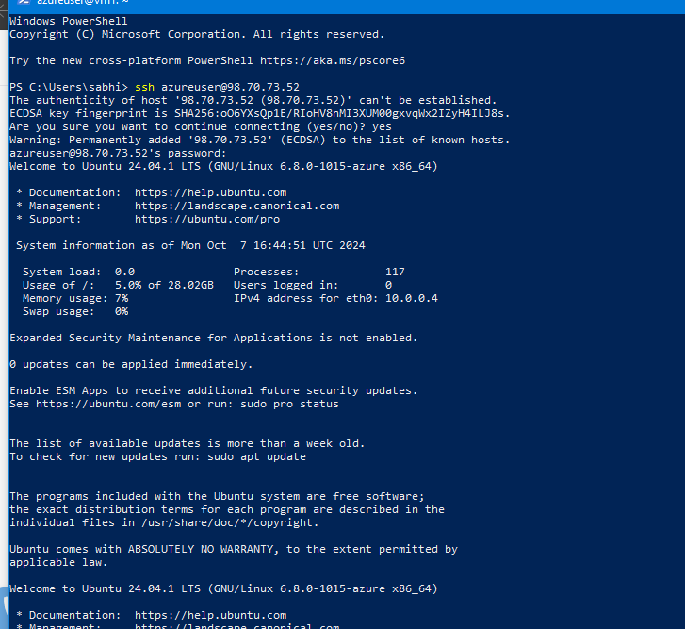

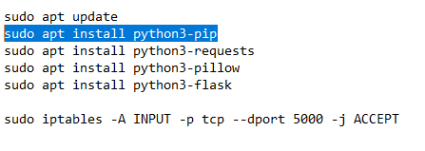**Code to install**

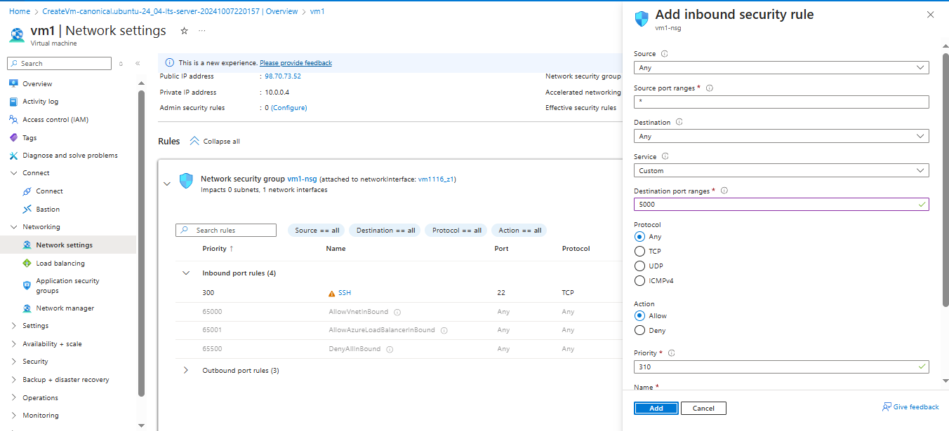

**Add port rule in vm port range as 5000**

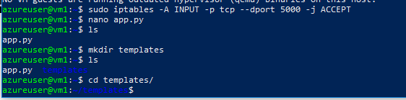

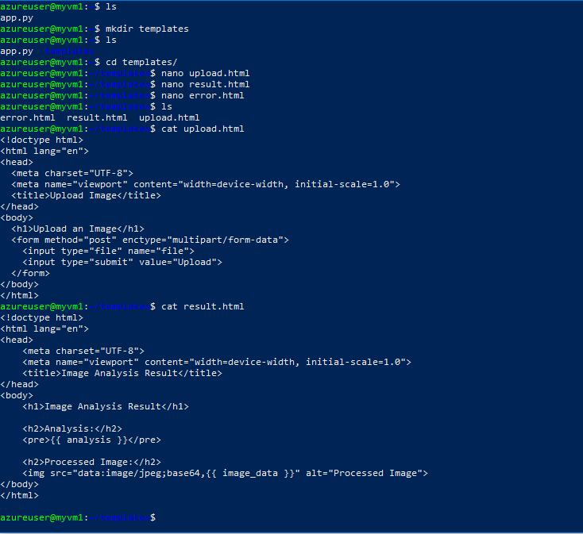 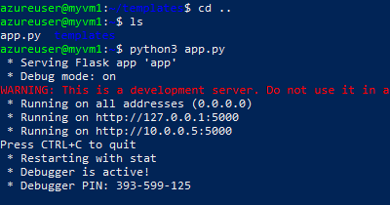

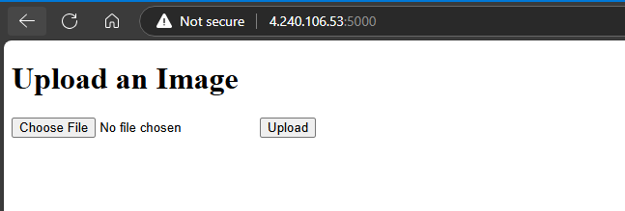

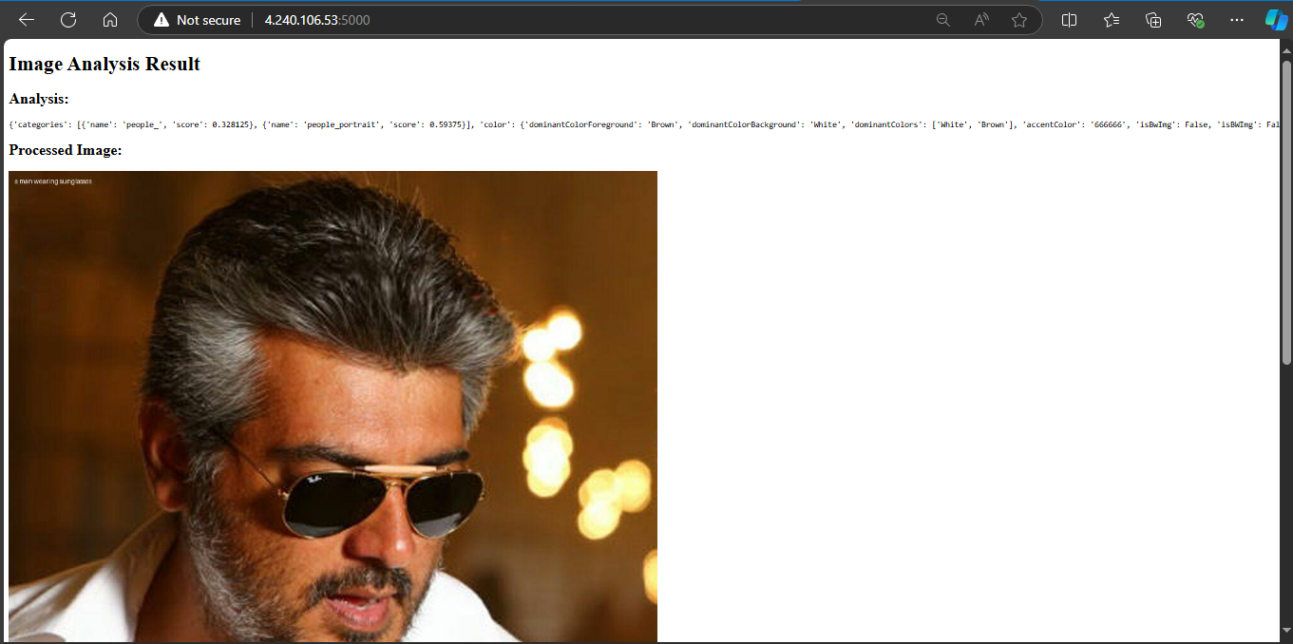

* **Created the Computer Vision account in portal.azure**
* **Then created linux disktop and ssh in to it**
* **Installed some codes like sudo apt install python3-pip,sudo apt install python3-requests, sudo apt install python3-pillow, sudo apt install python3-flask**
* **After install added the nano app.py and added the code into it**
* **The entered some codes like mkdir template , cd templates/ , la**
* **Then added the nano value like update.html, result.html, error.html**
* **After viwing that by cat option added the codes like cd .., python3 app.py to view the details**
* **Add port rule in vm port range as 5000**
* **Searched that by using http port and ip address and the port number (eg:http//4.240.106.53:5000)**
* **Then choose the image and upload it the result will bee executed**

**3. Speech to text and Text to speech**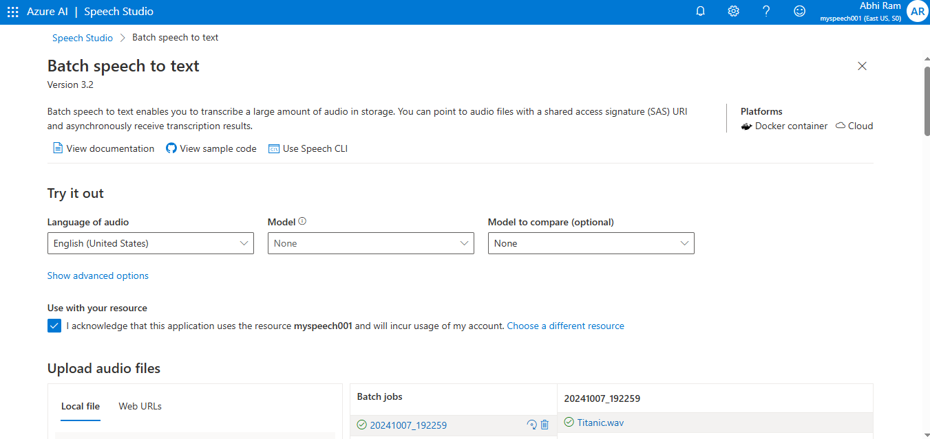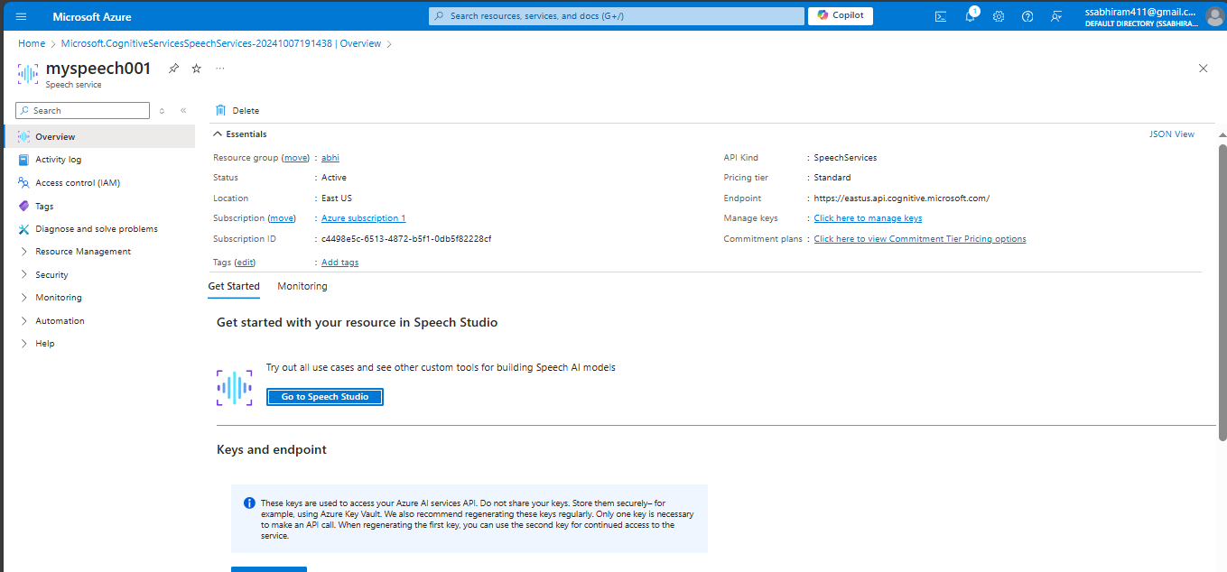

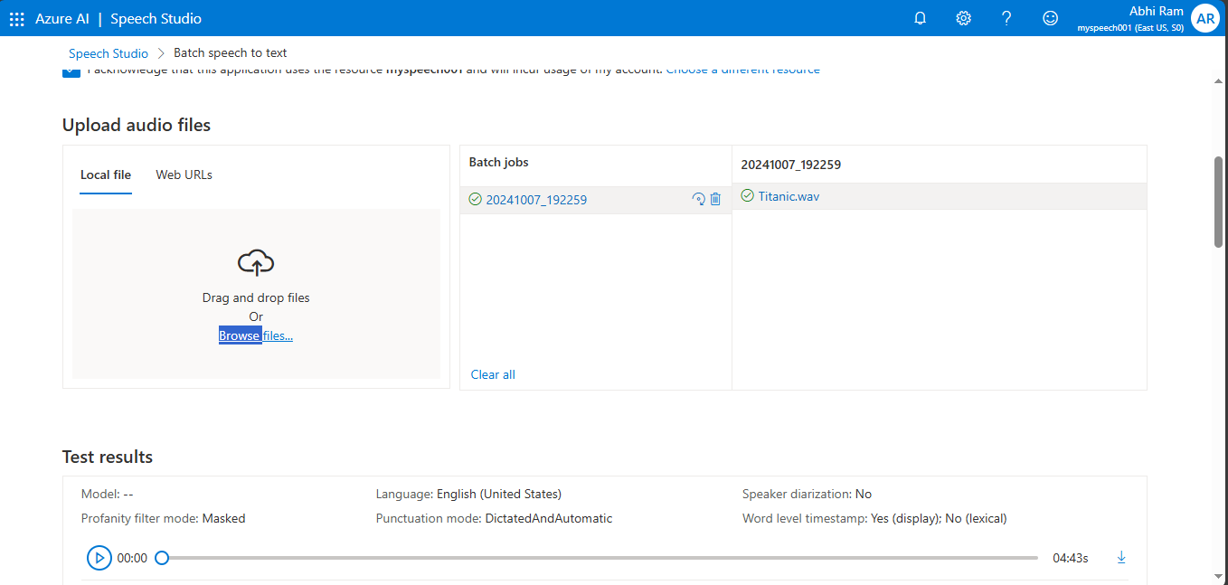

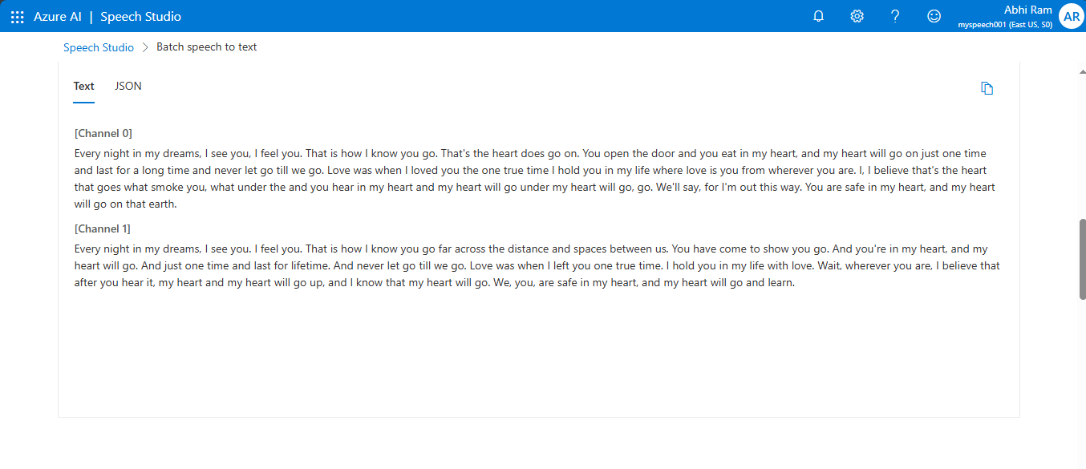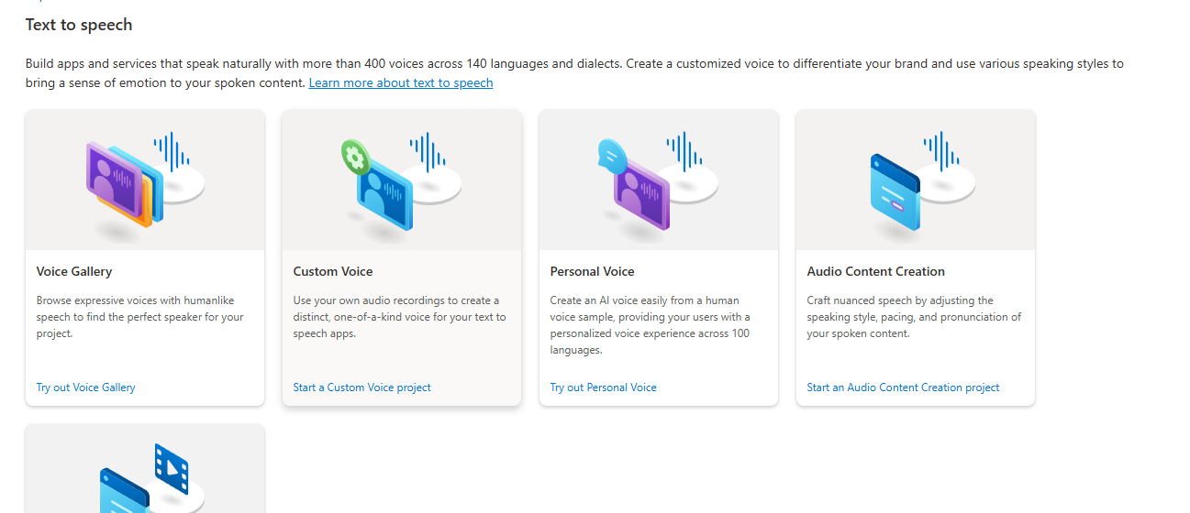

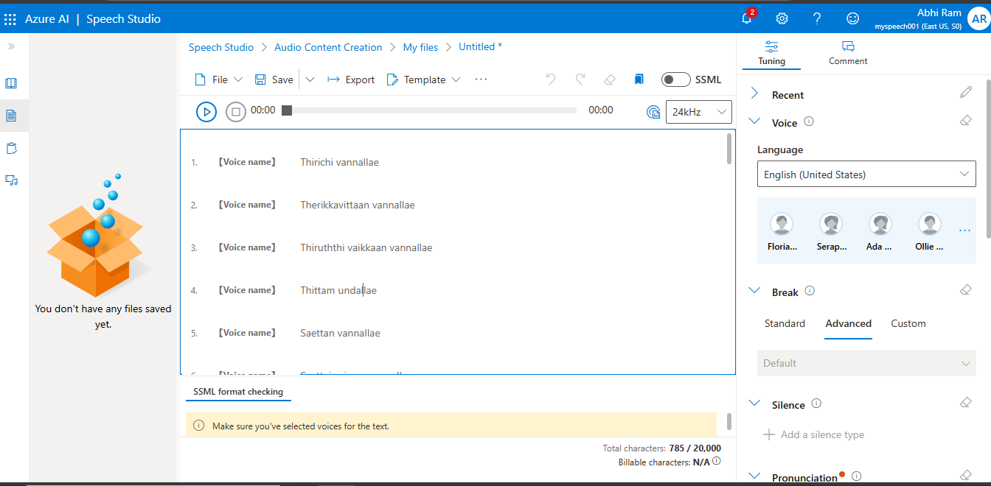

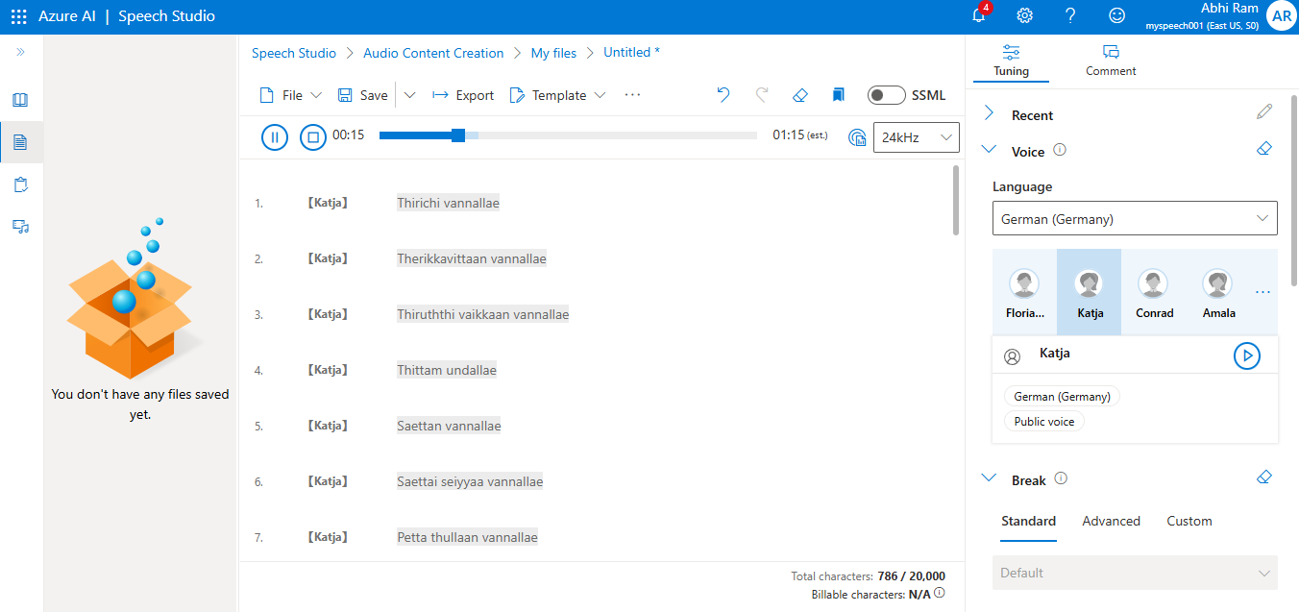

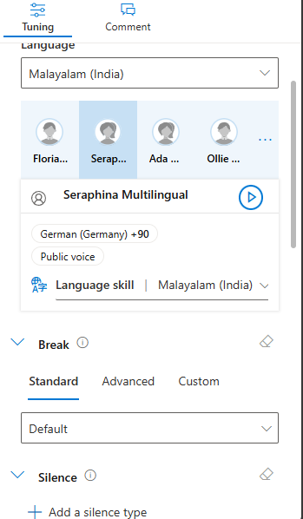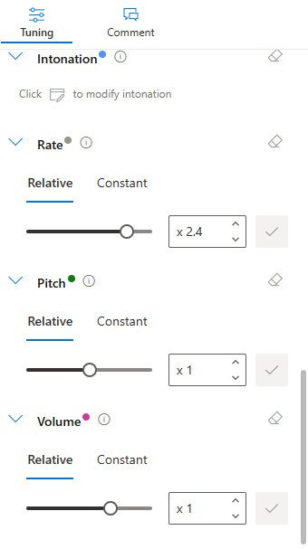

* **Created a speech services in cognative services and deployed it**
* **Selected speech studio from the sector and then selected one speech to text file**
* **Added the pre recorded audio file and exected the process**
* **Same in the speech studio I choosed the text to speech option and tried text to speech**
* **In that I added the uploaded the text and executed it there is also an audio change optin in it**
* **It can change the voice , language , modify the voice etc.**
* **There is also multiple ways to create this speech to text and text to speech option**
* **By the help of VM by executing the code what I done in my translator**